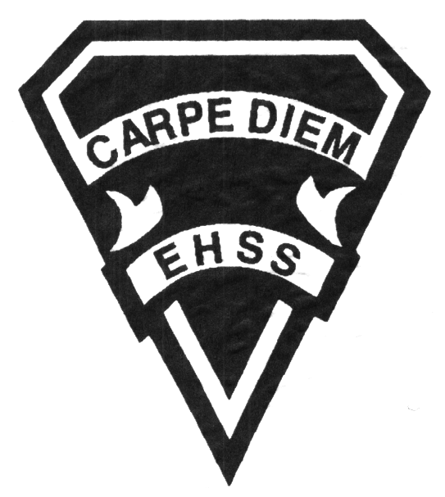

**2019/2020**

### Canadian History in the Twentieth Century (Academic/Enriched)

**Social Sciences Department**

## Earl Haig

SecondarySchool

# **CHC2D**

**Evaluation Profile & Outline**

**Course Description/Rationale/Overview:** This course explores Canadian participation in global events and traces our development as a nation through the changes in population, economy, and technology. Students analyse the elements that constitute Canadian identity, understand and interpret the stories of both individuals and communities, and study the evolution of political and social structures.

**Class Requirements:** Students should have materials specified by the subject teacher at the beginning of the year.

The textbook for this course is Creating Canada. Students will be issued this book at the beginning of the course. The replacement cost for this textbook $90.00.

**Assessment and Evaluation Strategies**

Students will also be expected to complete assessment activities of a formative nature in order to learn and to practice the specific expectations that will compose the summative evaluations. Examples of formative assessment may include homework checks, quizzes, peer assessment, presentations, reflection writing, role-play scenarios and observation.

Each unit or strand of the course will be evaluated using summative evaluations. Examples of summative evaluations are tests, case studies, interviews, reports, presentations, seminars, debates, research and other writing assignments.

**Late and/or Missed Evaluation**

##### Late Assignments*

For each assignment, the teacher will inform students of the due date. The teacher may decide to create an ultimate deadline. If an assignment is submitted after the deadline, the teacher may deduct marks up to and including the full value of the assignment.

**Missed Tests**

It is the student’s responsibility to make arrangements, ahead of time, for any tests/quizzes that are missed. If a student misses a test/quiz for an unforeseen reason such as illness, the student must bring a note signed by a parent or guardian**. Alternatively a medical certificate may be requested by the teacher.** The student must be prepared to write the test/quiz immediately upon return to school at a time determined by the teacher. Once the tests/quizzes have been evaluated and returned, students will not be able to make up a missed test - a mark of zero will be assigned.

**Subject-Specific/Department Information**

Teachers in the Social Sciences Department can be reached at (416) 395-3210, ext. 20075 or 20085. Parents wishing to meet with a teacher are requested to make an appointment with the teacher prior to coming to the school.

**Learning Skills\***

**Responsibility** – meets deadlines; takes responsibility for own behaviour

**Organization** – establishes priorities and manages time; uses information, technology and resources top complete tasks time management

**Independent Work** – follows instruction with minimal supervision; uses class time appropriately to complete tasks

**Collaboration** – accepts an equitable share of work in a group; builds healthy peer relationships; works with others to achieve group goals

**Initiative** – looks for opportunities for learning; demonstrates curiosity; approaches new tasks with a positive attitude

**Self-regulation** – sets own goals and monitors own progress; seeks assistance with needed; makes an effort with responding to challenges

###### Final Mark

The final mark for this course will be determined based upon an accumulation of marks from unit summative activities and from a final summative evaluation

**Year’s Work 70%**

This is a culmination of evaluations that have been completed throughout the year. It may include tests, presentations, research, or topic specific assignments.

**Final Summative Evaluation 30%**

This summative activity will comprise of an assignment (10%) to be completed near the end of the course and a final exam (20%).

**Achievement Categories and Weighting**

* **Knowledge / Understanding – 35%**

Knowledge of facts and terms; understanding of concepts, principles, guidelines and strategies; understanding of relationships among concepts.

* **Application – 20%**

Synthesizing knowledge and understanding into new and familiar contexts as well as making connections between various contexts.

* **Thinking Inquiry – 30%**

Formulating questions; planning, selecting strategies and resources; analyzing and interpreting information, and forming conclusions.

* **Communication – 15%**

Communication of information and ideas, communication for different audiences, use of various forms of communication.

*From: Ontario Ministry of Education. *Growing Success: Assessment, Evaluation, and Reporting in Ontario Schools*. Toronto: Ministry of Education, 2010, 11.



**2019/2020**

##### Canadian History in the Twentieth Century

**Social Sciences Department**

## Earl Haig

SecondarySchool

# **Course Code**

**Evaluation Profile & Outline**

**Course Outline:**

**Unit 1: Canada and World War I**

This unit examines Canada’s reasons for entering World War I and the contributions made by Canadians on the battlefield and at home. It also reflects on how Canada changed as a result of this participation.

**Unit 2: The Roaring Twenties and Dirty Thirties**

This unit examines the years of turmoil between the two World Wars highlighting the post-war problems and the stock market collapse in the late 1920’s It focuses on how individuals and governments responded to the many social, economic and political challenges that Canadians faced.

**Unit 3: Canada and World War II**

This unit examines the events in Europe that led to World War II and our very significant role during that war. A significant part of this unit focuses on the transformation of the country from a former British colony into a wealthy, independent nation with a role to play on the international stage.

**Unit 4: Canada in the Post-War Era**

This unit looks at the years 1945-1969 with an emphasis on international themes global trade, peacekeeping, continental defense, human rights) and the revival of Quebec nationalism.

**Unit 5: Years of Change**

This unit examines the turbulent years from 1970-1982. The focus is on the political, economic and constitutional directions of Pierre Elliot Trudeau’s government.

**Unit 6: Toward the New Millennium**

The final unit examines the last two decades of the twentieth century. It highlights developments in the women’s movement, Canadian – American relations, globalization and our growing ethnicity.